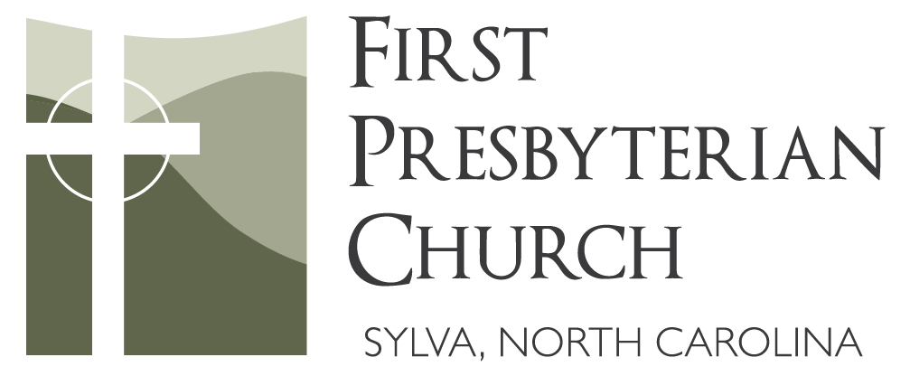

A Service for the Lord’s Day
April 28, 2024
Fifth Sunday of Easter

Welcome & Announcements

Prelude: “Amazing Grace” arranged by Jack Schrader

Call to Worship: Psalm 32:1-2, 8-11 (NLT)
Leader: Oh, what joy for those whose disobedience is forgiven, whose sin is put out of sight.
People: Yes, what joy for those whose record the Lord has cleared of guilt, whose lives are lived in complete honesty.
Leader: The Lord says, “I will guide you along the best pathway for your life.”
People: “I will advise you and watch over you.”
Leader: “Do not be like a senseless horse or mule that needs a bit and bridle to keep it under control.”
People: Many sorrows come to the wicked, but unfailing love surrounds those who trust the Lord.
Leader: So rejoice in the Lord and be glad, all you who obey him!
People: Shout for joy, all you whose hearts are pure!

*Opening Hymn #682: “Before the Throne of God Above”

*Prayer of Confession

*Assurance of Pardon & Passing of the Peace
Leader: May the peace of Christ be with you.
People: And also with you.

*Hymn #361: “Because He Lives”
Because he lives, I can face tomorrow, because he lives, all fear is gone;
Because I know he holds the future, and life is worth the living, just because he lives!
Children’s Message
We invite children ages 3 through 2nd grade to come forward for a brief lesson, after which they may go back to their seats or on to Children’s Church.

Anthem: “Love Unmeasured, Love of God” by Lloyd Larson

From the edge of the horizon, farther than the eye has seen,
From the mountain to the valley flows an ever growing stream.
Living water for the thirsty, river flowing deep and broad,
Springing from the throne of heaven, love unmeasured, love of God.
O how blessed the one who trusts in God, Firmly planted he shall stand
Like a tree beside the river, drinking deeply from God’s hand.
Fearing not the heat of noon day, bending not when storm winds blow,
Never failing to be fruitful, God has promised, it is so.

Scripture Lesson: Luke 15:11-32 page 912 / lg print page 1611
Leader: This is the Word of the Lord.
People: Thanks be to God.

Sermon: “Resurrection: The Two Sons” Rev. Blake Daniel

*Hymn of Response #360: “You Are My King” (Amazing Love)

*Affirmation of Faith: from The Theological Declaration of Barmen
As Jesus Christ is God’s assurance of the forgiveness of all our sins, so in the same way and with the same seriousness is he also God’s mighty claim upon our whole life. Through him befalls us a joyful deliverance from the godless fetters of this world for a free, grateful service to his creatures. We reject the false doctrine, as though there were areas of our life in which we would not belong to Jesus Christ, but to other lords—areas in which we would not need justification and sanctification through him. Rather, speaking the truth in love, we are to grow up in every way into him who is the head, into Christ, from whom the whole body is joined and knit together.

Prayers of the People & The Lord’s Prayer
Our Father, who art in heaven, hallowed be thy name, thy kingdom come, thy will be done, on earth as it is in heaven. Give us this day our daily bread. And forgive us our debts, as we forgive our debtors. And lead us not into temptation, but deliver us from evil. For thine is the kingdom, and the power, and the glory, forever. Amen.

Tithes & Offerings: “Just As I Am” by William Bradbury
*Please stand as you are able.
*Doxology #965

*Closing Hymn #876: “God, Whose Giving Knows No Ending” (verses 1 & 2)

*Benediction

*Congregational Response #876: “God, Whose Giving Knows No Ending” (verse 3)

Postlude #685: “I Sought the Lord, and Afterward I Knew He Moved My Soul to Seek Him”
We invite you to join us for coffee fellowship in the Fellowship Hall following the service!

OUR MISSION
To make disciples who love Jesus Christ, love the church, and love their neighbors as themselves.

TO OUR VISITORS
We are glad you are here! Please write your name and contact information in the visitor pad in your pew before you leave. We would love to send you a personal note of welcome. Please notify our Pastor if you are interested in joining our congregation as a member.

ANNOUNCEMENTS
- Mozart’s Requiem will be performed at WCU today, April 28 at 3pm in the Recital Hall of the Coulter Building. The performance is free and open to the public.
- Circles of Jackson County is hosting a Spring Luncheon on Wed., May 1 from 12:00-2:00pm at First United Methodist Church. Want to join our FPC table? A signup sheet is in the Fellowship Hall, or you can contact the church office or talk to Pastor Blake.
- Our next Family Night Supper is Wed., May 1 at 6:00pm in the Fellowship Hall. It's “Mexican Food” themed – potluck-style – so bring a Mexican dish or dessert to share. Bring extra food, if possible, since we will also be hosting the SMHS boys’ golf team!
- A Church Work Day will take place on May 4 from 9:00am-12:00pm. Projects will include weeding, planting, washing windows, paint touch ups, and decluttering (among other tasks). Come for as long or as little as you can to help us spruce up our church!
- The annual Presbyterian Women’s Birthday Offering will be taken on Mother’s Day, May 12. The next PW Circle meeting will be Thurs., May 16 at 10:00am in the Mary Jay Patten Center youth room, focusing on Lesson 8. All women are invited to attend.
- Community Vacation Bible School will take place on May 28-31 from 9:00am-12:00pm at Bridge Park. All children in pre-K through middle school are invited to attend! Registration and volunteer information will be posted soon, so be on the lookout.
A WORD ABOUT WORSHIP
Today’s affirmation of faith comes from The Theological Declaration of Barmen. It was written in the 1930s by a group of church leaders in Germany to help Christians withstand the challenges of the Nazi party and of the so-called “German Christians,” a popular movement that saw no conflict between Christianity and the ideals of Hitler’s National Socialism. The declaration proclaims the church’s freedom in Jesus Christ, who is Lord of every area of life. The church obeys Jesus as God’s one and only Word who determines its order, ministry, and relation to the state and the world around it.

CONTRIBUTIONS: 04-18-24 / 04-24-24
Regular: $746.69; Organ: $25.69; Total: $ 772.38
Online Giving: www.sylvapres.org/giving; Attendance: 96

SERVERS
Ushers & Greeters: James Walawender, David Noland, Sara Beth Foti
Acolyte: Thomas Hogan; Coffee Fellowship: Courtney & Drew Umphlett
Flowers: Christi Hooper & Johnny Phillips – In Memory of Martha Jane

PRAYER REQUESTS
Send prayer concerns or updates to our prayer email address: pray@sylvapres.org.
You may also call the church office at (828) 586-4256 to share a request.
Please contact our Pastor or Deacon of the Month if you or a loved one are in the hospital or in need.

CONTACT INFORMATION
Pastor: Blake Daniel
Administrative Assistant:
Jean Chance
Music Director: Courtney Umphlett
Organist/Pianist: Margaret Hale
Children & Youth Ministry Director: Heather Monar
Children’s Ministry Assistant:
Lilly Matheson
Treasurer: Judy Henderson
Financial Secretary: Grace Reed
Asst. Financial Secretary: Lynda Parlett
Deacon of the Month:
Jeff Pope – (828) 736-7867
Dianne Scott (alt) – (828) 506-5665
Church Office:
Phone: (828) 586-4256
Email: office@sylvapres.org
www.sylvapres.org

Physical address:
46 Presbyterian Drive
Sylva, NC 28779

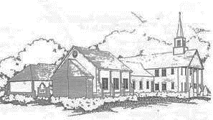
Mailing address:
P.O. Box 2152
Sylva, NC 28779

